FT8 Ressourcer
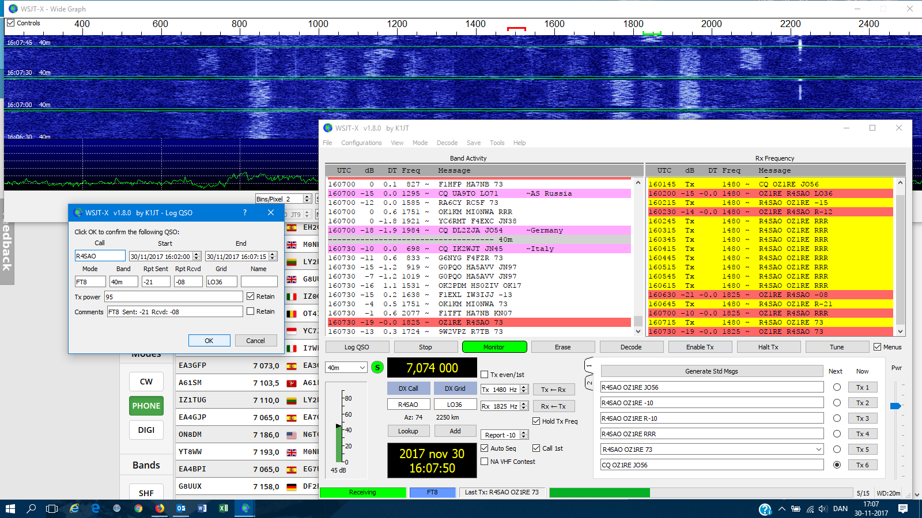
FT8 Hjemmeside og download af program:
https://physics.princeton.edu/pulsar/k1jt/wsjtx.html
Opsætningshjælp:
http://w4ti.com/wsjt-x-help-files/wsjt-x-configuration-guide/
FT8 Digital Mode Club:
http://ft8dmc.oe4yla.com/
https://www.facebook.com/groups/685845101611130/
https://www.facebook.com/groups/FT8.Digital.Mode/
Dansk FT8 Digimode:
https://www.facebook.com/groups/116378525717837/
Cluster:
https://www.pskreporter.info/pskmap.html
http://k7ar.net/ft8web/Default.aspx?FilterMode=ALL
http://hamspots.net/ft8/
Lidt fra K1JT:
https://w5fc.org/2017/07/15/new-digital-mode-from-k1jt-ft8/
Bouvet DX-pedition FT8 info:
https://www.bouvetdx.org/band-plan-frequencies/

